**Internship Report**

**Internet of Things and It’s Applications**

**DLithe Consultancy Services Pvt. Ltd.**



**Internship Report**

**Trainee/Intern Name:**

**Reg. no:**

**Period:**

**Job Assignment:**

**Organization:** DLithe Consultancy Services Pvt. Ltd.

**Supervisor’s Name:**

**Observations:**

**Submitted to**

Signature of Training Supervisor Signature of Co-ordinator

Date: Date:

**Letter of Transmittal**

To,

Program Co-ordinator

DLithe Consultancy services

Bengaluru

Dear Sir,

I am writing to submit my report on IoT Internship that I recently completed on Artificial Intelligence (AI) and Machine Learning (ML). The training program was an invaluable learning experience, and I am grateful for the opportunity to participate.

The training program covered various aspects of AI and ML, including basic concepts, algorithms, programming languages, and practical applications. I gained a comprehensive understanding of the role of AI and ML in modern technology and industry, and also gained hands-on experience with AI and ML tools and platforms. The training highlighted the potential of AI and ML to revolutionize various fields, including healthcare, finance, and manufacturing.

The report includes a detailed overview of the training program, including the topics covered, the learning objectives, and the outcomes achieved. It also provides observations and insights into the potential benefits and challenges of implementing AI and ML solutions in different fields.

I believe that the knowledge and skills that I acquired during the training program will be valuable to our organization. AI and ML are rapidly becoming more ubiquitous in various industries, and the ability to work with AI and ML tools and platforms will be increasingly important for our organization's success.

I hope that the report provides useful insights into the benefits of on-job training and the potential of AI and ML.

Sincerely,

Name:

Reg. no:

**Table of Contents**

Introduction5

Project Overview6

Problem statement and Solution6-7

Methodology7-8

Tools and technologies 9

System requirements 9-10

Hardware requirement9-10

Software requirement9-10

Schematics and Code11-12

Results 12

Training Experience13

Key Learnings14

Challenges15

Conclusion15

**Introduction**

Artificial Intelligence and Machine Learning are two of the most popular and rapidly growing fields in computer science. They are transforming the way we live, work, and interact with technology. The purpose of this report is to provide an overview of my Internship Training experience on Artificial Intelligence and Machine Learning, and to describe the various concepts and techniques that I learned during the training.

The primary objectives of this internship were multifaceted. They encompassed gaining a comprehensive understanding of AI and ML, mastering key techniques, and applying this knowledge through practical projects. The journey aimed to bridge the gap between theoretical concepts and real-world applications, fostering a holistic and immersive learning experience.

The training began with a robust exploration of the fundamentals, ensuring that all participants, regardless of their prior knowledge, had a solid foundation. Concepts such as supervised and unsupervised learning, regression, and classification were elucidated, setting the stage for more advanced topics.

The curriculum systematically covered a variety of machine learning techniques and algorithms. From traditional methods to contemporary approaches, participants were exposed to a range of tools in their analytical toolkit. Decision trees, support vector machines, and clustering algorithms were among the key topics covered.

**Overview**

The Internship Training program on Artificial Intelligence and Machine Learning that I participated in was conducted by a technology company. The program was designed to provide a comprehensive overview of the latest advancements in the field of AI and ML, and to equip participants with the skills and knowledge required to build intelligent systems and applications.

The training program consisted of practical hands-on sessions. The lectures covered a wide range of topics, including the fundamentals of AI and ML, various techniques and algorithms used in machine learning, and the latest developments in deep learning and neural networks. The practical sessions involved working on various projects and implementing machine learning algorithms on real-world datasets.

Fundamentals of AI and ML:

The program commenced with an in-depth exploration of the fundamental principles underpinning Artificial Intelligence and Machine Learning. Topics included basic concepts, terminology, and the historical evolution of these fields.

Machine Learning Techniques and Algorithms:Lectures delved into a diverse array of machine learning techniques and algorithms. Participants gained insights into supervised and unsupervised learning, reinforcement learning, and ensemble methods. Practical demonstrations elucidated the application of these algorithms in real-world scenarios.

Deep Learning and Neural Networks:

To stay abreast of the latest advancements, the program extensively covered deep learning and neural networks. Participants were introduced to the architecture of neural networks, optimization techniques, and hands-on experience in building and training deep learning models**.**

**Project / Use Case implementation**

Hate speech can be defined as any speech that targets a group of people based on their race, religion, ethnicity, national origin, sexual orientation, or gender identity. Hate speech is often used to spread hate and bigotry. It can also be used to intimidate and threaten people. It can make people feel isolated, anxious, and scared. It can also lead to hate crimes.

 Machine learning is a type of artificial intelligence that can be used to learn from data. It can be used to find patterns in data

These algorithms can analyze text and identify hate speech. They can also be used to determine the tone of a text. This can be used to identify hate speech that is disguised as jokes or sarcasm. Automated hate speech detection is an important tool in combating the spread of hate speech, particularly in social media.

1. Collect a hate speech dataset: You will need a dataset of labelled examples of hate speech and non-hate speech. There are many publicly available datasets that you can use for this purpose, such as the Hate Speech and Offensive Language dataset or the Twitter Hate Speech dataset.

2. Pre-processing the data: Pre-processing involves cleaning and transforming the raw text data into a format that the machine learning algorithm can use. Some common pre-processing steps include tokenization, stop word removal, and stemming.

3. Feature extraction: This step involves extracting relevant features from the pre-processed text. You can use techniques such as a bag of words, TF-IDF, or word embeddings to create features that can be used by the machine learning algorithm.

 4. Train the model: Divide your dataset into training and validation sets. Use the training set to train your machine learning model. SVM and Naive Bayes are popular choices for hate speech detection because they are relatively easy to implement and can work well with high-dimensional sparse feature vector

5. Evaluate the model: Use the validation set to evaluate the performance of your model. Common evaluation metrics include precision, recall, F1 score, and accuracy. Deploy the model: Once you have trained and evaluated your model, you can deploy it to classify new text as hate speech or non-hate speech.

Data Preprocessing: The collected data was preprocessed to remove duplicates, missing values, and outliers. Data cleaning techniques such as imputation, normalization, and scaling were applied to prepare the data for analysis.

Feature Selection: The relevant features were selected for analysis based on their importance and correlation with the target variable.

Clustering Algorithm Selection: Different clustering algorithms such as K-Means, Hierarchical Clustering, and DBSCAN were evaluated and compared to select the best algorithm for the data.

Model Training: The selected clustering algorithm was trained on the preprocessed data to generate clusters of credit card customers.

Cluster Analysis: The generated clusters were analyzed and interpreted to gain insights into the spending patterns and preferences of each cluster.

Results Visualization: The results of the analysis were visualized using charts and graphs to make it easy for stakeholders to understand and interpret the findings.

**Methodology:**

**1.Understanding the Problem:**

- Clearly figuring out the challenge of finding mean words in online text.

- Learning why it's hard but important to stop unkind words online.

**2. Getting the Examples:**

- Collecting different kinds of online messages, some with mean words and some without.

- Making sure each message is labeled correctly as mean or not mean.

**3. Getting the Texts Ready:**

- Cleaning up the messages by removing things we don't need and making all the letters the same.

- Using special tricks to make the messages better for the computer to understand.

**4. Turning Words into Numbers:**

- Changing the messages into numbers so the computer can work with them.

- Trying out other things that might help the computer understand the messages better.

**5. Choosing the Computer's Tools:**

- Picking which computer tools work best for understanding messages, like Decision Trees or Support Vector Machines.

- Trying out different methods to see which one works the best.

**6. Teaching the Computer:**

- Splitting the messages into two groups: one to teach the computer and another to see how well it learned.

- Helping the computer learn by showing it lots of examples.

**7. Checking How Well It Learned:**

- Seeing how good the computer is at finding mean words by using numbers like accuracy and precision.

- Fixing any problems to make the computer better.

**8. Making the Computer Smarter:**

- Changing some settings to make the computer even better.

- Trying different ways to make sure the computer is doing a good job.

**9. Being Fair and Honest:**

- Making sure the computer isn't treating people unfairly and is being honest about finding mean words.

- Fixing any mistakes the computer makes.

**10. Putting It Where It's Needed:**

- Putting the computer program where people can use it easily.

- Watching how it does in the real world and listening to what people think.

**11. Making It Better All the Time:**

- Changing the program based on what people say and new things happening online.

- Always trying to make the program better at stopping mean words.

**Tools and Technologies Used:**

During the project, I used various tools and technologies such as:

Python: for data preprocessing, feature selection, and model training.

Scikit-Learn: for clustering algorithm selection and model training.

Matplotlib: for data visualization.

Google colab Notebook: for creating and running the code.

**System Requirements:**

**1.Hardware:**

- Processor: Multi-core processors (e.g., Intel Core i5 or higher) for faster computation.

- RAM: Minimum 8 GB RAM for efficient data processing and model training.

- Storage: Adequate storage space for datasets, models, and related files.

**2.Software:**

- Python: Latest version of Python (3.x) as the primary programming language.

- Libraries : Key libraries such as scikit-learn, NLTK, pandas, NumPy, and TensorFlow or PyTorch for machine learning and natural language processing tasks.

- Development Environment : Jupyter Notebooks or an integrated development environment (IDE) like VSCode for code development.

**3. Dependencies:**

- NLP Resources: Downloading necessary resources like NLTK corpora and spaCy models.

- Word Embeddings: If using pre-trained word embeddings (e.g., Word2Vec, GloVe), download and incorporate them into the project.

**4. Internet Connection:** - A stable internet connection for downloading datasets, libraries, and additional resources.

**5. GPU (Optional):**

- For large-scale machine learning tasks, having a compatible GPU (NVIDIA CUDA-enabled) can significantly accelerate model training.

**6. Version Control:**

- Utilizing version control systems (e.g., Git) to track code changes and collaborate effectively.

**7. Documentation:**

- Software for creating and maintaining project documentation (e.g., Sphinx or MkDocs).

**8. Collaboration Tools (Optional):**

- Collaboration tools such as Slack, Trello, or Asana for effective communication and task management if working in a team.

**9. Web Framework (Optional):**

- If deploying the model as a web application, familiarity with web frameworks like Flask or Django may be required.

**10. Cloud Services (Optional):**

- Cloud platforms like AWS, Google Cloud, or Microsoft Azure can be utilized for scalable computing resources and model deployment.

**Reference Images:**

<https://colab.research.google.com/drive/15Kk8txSCSlK9VrLg6kszb1w_pa9U13xU?usp=sharing#scrollTo=PbsWX5nE7rs7>

**Wordcloud:**

Hate speech:

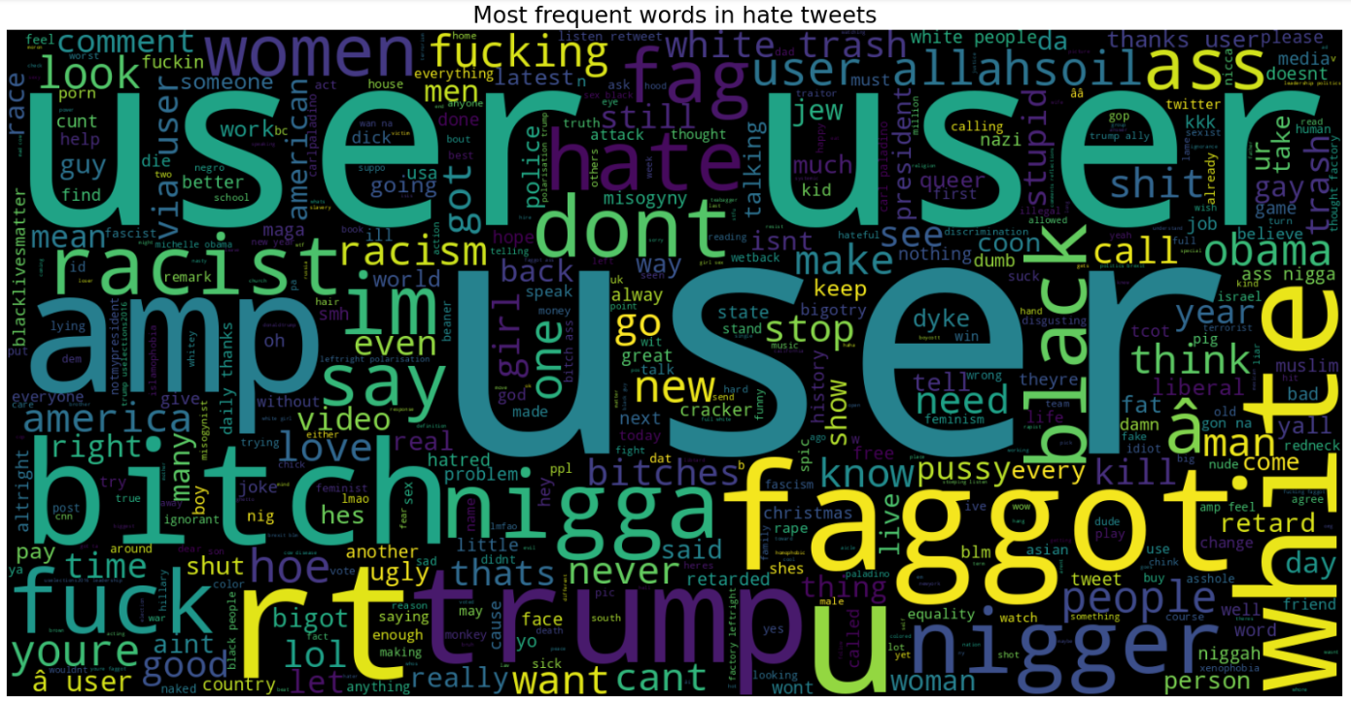

Non Hate speech:

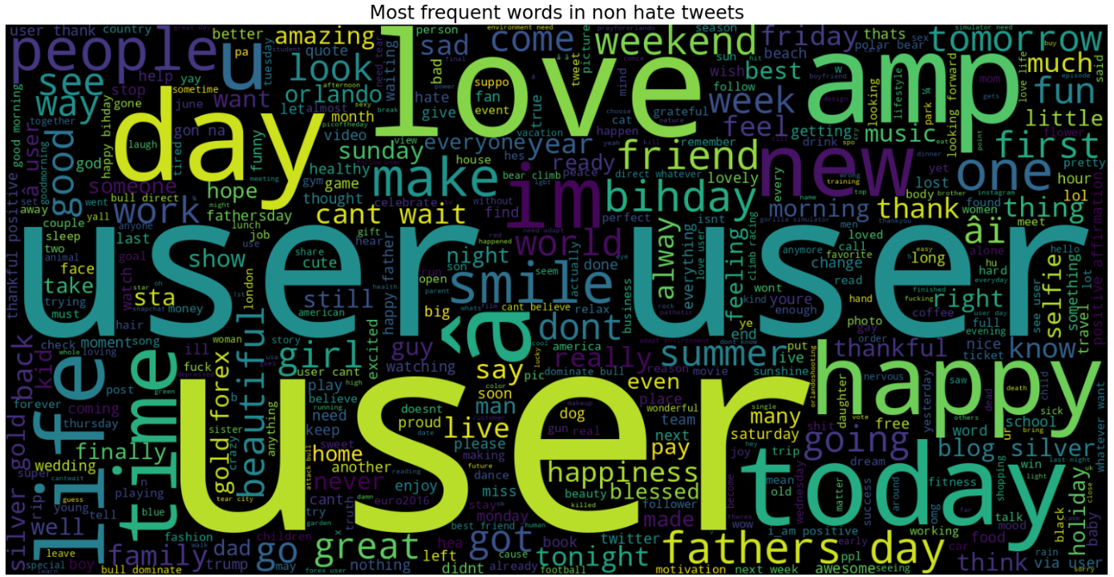Confusion matrix:

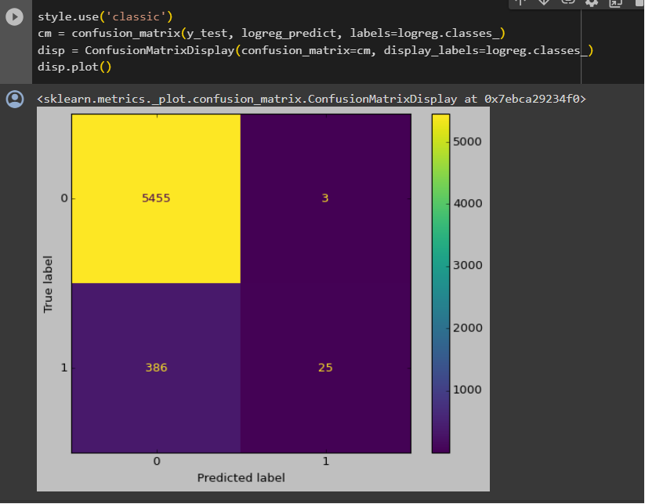

**Schematic and codes**

**Accuracy:**

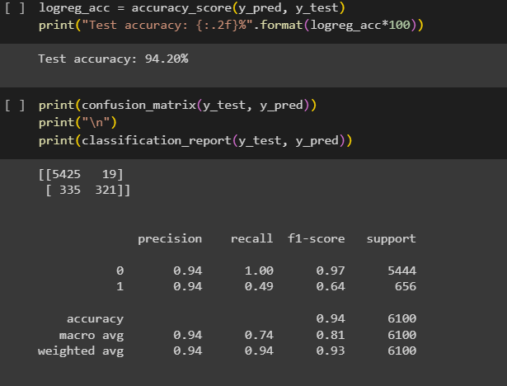

**Result:**

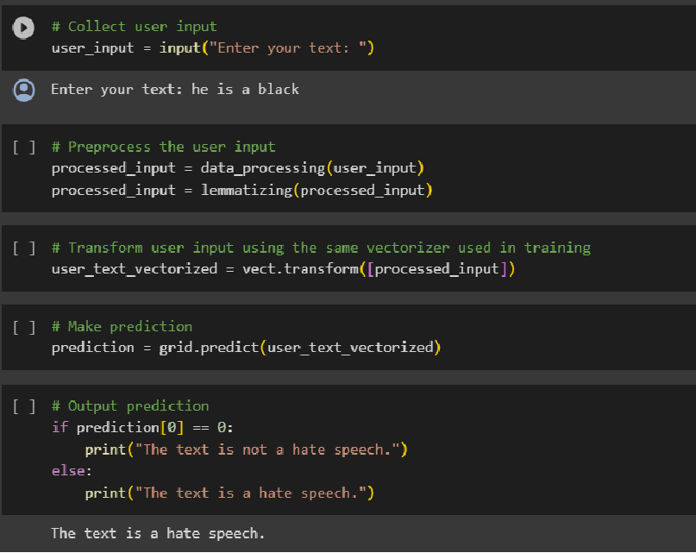

**Training Experience**

Hands-on Learning: My training program was designed to provide hands-on experience with AI and ML tools and technologies. I was given the opportunity to work on real-world projects and problems, which helped me develop practical skills and apply theoretical concepts.

Mentorship: I was fortunate to have a mentor who was an experienced AI and ML professional. My mentor provided guidance, feedback, and support throughout my training program, which was invaluable in my learning journey.

Collaboration: One of the most exciting aspects of my training program was the opportunity to work with a team of professionals from different backgrounds. We collaborated on projects and shared ideas, which helped me develop my communication and collaboration skills.

Exposure to Industry Trends: I was able to stay up-to-date with the latest industry trends and developments in AI and ML through various workshops, seminars, and conferences. This helped me gain a broader perspective on the field and prepare for future challenges.

Use of Industry-standard Tools and Technologies: During my training, I had the opportunity to work with industry-standard tools and technologies such as Python, TensorFlow, Keras, and Scikit-Learn. This allowed me to gain practical skills that are in demand in the industry.

Importance of Data Preparation: One of the most important lessons I learned during my training was the critical role of data preparation in the success of AI and ML projects. I learned how to collect, clean, and preprocess data to make it suitable for training models.

Iterative Process: I also learned that developing an AI or ML model is an iterative process that requires a lot of experimentation and tweaking. It is essential to have a feedback loop that allows for continuous improvement of the model.

**Observations:**

During my on-job training on Artificial Intelligence (AI) and Machine Learning (ML), I was able to observe several important things. Here are my observations:

Importance of Data: The success of AI and ML models heavily depends on the quality and quantity of data available for training. Without the right data, it is difficult to build accurate and effective models. Therefore, data preparation and cleaning is a critical step in the ML pipeline.

Diversity of Applications: AI and ML can be applied in various domains, from healthcare to finance, from retail to transportation. The applications are diverse and endless, and the potential impact of AI and ML on society is enormous.

Iterative Process: Developing an AI or ML model is an iterative process that requires a lot of experimentation and tweaking. It is essential to have a feedback loop that allows for continuous improvement of the model.

Algorithm Selection: There is no one-size-fits-all algorithm for ML. The choice of algorithm depends on the specific problem being solved, the type of data available, and the desired output. It is crucial to have a good understanding of different algorithms and their strengths and weaknesses.

Ethics and Bias: The development of AI and ML models raises ethical and bias concerns. Biases can be introduced through the data used to train the model, and it is crucial to ensure that the model is fair and unbiased.

Importance of Visualization: Visualization is a powerful tool for exploring and understanding data. It can help identify patterns and trends in the data, which can be used to improve the model's performance.

Role of Domain Experts: Domain experts play a critical role in the development of AI and ML models. They have a deep understanding of the problem and the data, which can help identify the right features and improve the model's performance.

Importance of Communication: Effective communication is critical when working with cross-functional teams. Clear communication of goals, expectations, and results is essential for success.

**Key Learnings**

During the training program, I learned a range of skills and concepts related to Artificial Intelligence and Machine Learning. Some of the key skills that I acquired are:

Understanding of Artificial Intelligence: I gained a comprehensive understanding of Artificial Intelligence, including the various subfields such as Machine Learning, Deep Learning, and Natural Language Processing.

Machine Learning Concepts and Algorithms: I learned about various Machine Learning concepts and algorithms, including Supervised and Unsupervised Learning, Decision Trees, Random Forests, Support Vector Machines, and K-Nearest Neighbors.

Deep Learning and Neural Networks: I gained a deep understanding of Deep Learning and Neural Networks, including Convolutional Neural Networks and Recurrent Neural Networks.

Programming Skills: I developed strong programming skills in Python, including libraries such as Numpy, Pandas, and Matplotlib.

Data Preprocessing and Analysis: I learned various techniques for data preprocessing and analysis, including Data Cleaning, Data Wrangling, and Exploratory Data Analysis.

**Applications of AI and ML**

* Artificial Intelligence (AI) and Machine Learning (ML) are two of the most promising and rapidly developing technologies today, with numerous potential applications across various fields. Here are some examples of how AI and ML are being applied:
* Healthcare: AI and ML can be used in healthcare to diagnose diseases, analyze medical images and scans, and personalize treatments based on patient data. For example, ML algorithms can be trained to detect cancer in medical images with high accuracy, and AI-powered chatbots can assist patients in diagnosing and treating common illnesses.
* Finance: AI and ML can be used in finance to detect fraud, analyze market trends, and improve risk management. For example, ML algorithms can analyze large amounts of financial data to detect fraudulent transactions, and AI-powered chatbots can assist customers in managing their finances and investments.
* Manufacturing: AI and ML can be used in manufacturing to optimize processes, reduce costs, and improve quality control. For example, ML algorithms can analyze production data to identify inefficiencies and optimize production processes, and AI-powered robots can be used for repetitive and dangerous tasks.
* Transportation: AI and ML can be used in transportation to improve safety, reduce congestion, and optimize routes. For example, ML algorithms can analyze traffic data to predict and mitigate congestion, and AI-powered vehicles can assist in autonomous driving.

**Conclusion**

In conclusion, our project on hate speech detection has shown that using machine learning tools can help address the serious issue of hateful language. We used techniques like lemmatization, removing common words, and TF-IDF to build a strong model that can identify hate speech. The steps we took to clean and improve the data, create new features, and choose the right algorithm made a big difference in how well the model works.

However, we faced challenges, like dealing with imbalanced data and keeping up with new types of hate speech. The ethical concerns of using these models, like the possibility of bias, and the importance of responsible AI need to be kept in mind. Working closely with diverse communities and continuously improving the model based on user feedback is crucial for making it fair and accurate.

Our project goes beyond just technical achievements; it highlights the broader responsibility we have in society to fight against hate speech. As we deal with the changing ways people communicate online, our work stresses how important it is to be proactive and adaptable in creating a digital environment that is safer and more respectful for everyone..